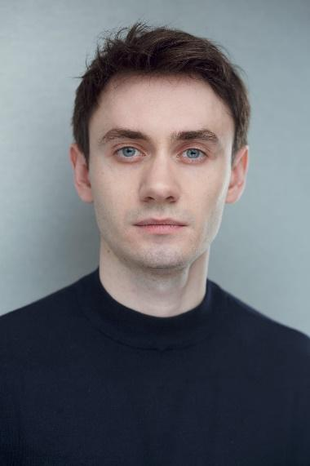
Name: Ilya
Surname: Khodyrev
Age: 31
Born: Russian Federation, Kemerovo.
Citizenship: Russian federation.
Location: Berlin, Hamburg.
_____________________________________________________________________________________

Working experience:
- 2016 Cofounder of the “Saint-Petersburg Urban Theatre”. We made it with twenty other actors and I has got a non-refundable private investment for the first performance, about 6000 euro. (Годы)
- 2016 -2022 Theatre actor in “Saint-Petersburg Urban Theatre”
7 lead parts and 4 supporting parts.
- 2016 - 2020 Junior project manager in “Saint-Petersburg Urban Theatre” . As a PM I successfully managed with following responsibilities:
- props, costumes and decorations transfer,
- employees hiring (lighting designers, stage staff and etc),
- lighting and music equipment rent

- 2016 -2019 Playwright editor and writer: creative editing of drama- and screenplays
- From 2017 till 2019 worked in “theatre of Russian enterprise, named after A. Mironov” as an actor in musical “Straw hat” (lead role)
- In summer of 2017 and 2019 I have made performances with German theatre company “wheels” and actors from Ukraine and Italy in Berlin and Kharkiv.
- 2021 – 2022 worked as an actor in “American Theatre in Moscow”. Have played a main part in musical “la-la-land” (lead role)
- 2020 – present. I have worked in a cinematography as an actor in Moscow (art pictures studios, Alians studio, etc) more than 15 roles, included lead role in a feature film “the choice” (in postproduction now), 5 roles in short movies, also supporting roles in tv-series).
- Inclusive games host and supervisor at Games festival “What are the rules?” in contemporary museum “GES 2”. I have supervised and hosted a game for adults and children with neurodifferencies and disabilities.
- Founder of Acting school for non-professional actors. I do teaching them stress relief methods, express emotions, got to know their body’s, also voice technics. Stanislavskyi, Michael Chekhovs and physical theatre trainings helps me to create specific program for non-actors, who wants to know something new about their own psychophysics and improve communicative and social skills.
I know all about movie production from preproduction till premiere, because I was inside of industry and before war I have worked on my own project and was preparing to pitch my original show

Education:
2008 – 2010 Krasnodar university of culture and arts.
Specialization: theatre director.
2010 – 2011 Moscow art theatre school.
Specialization: drama actor.
2012 – 2016 Saint-Petersburg academy of theatre and arts (baccalaureate)
Specialization: drama actor.
2019 educational program of international summer festival “Access point”
I was a part of a team, who created best performance within the site-specific laboratory
(performance got a prize “best experiment” golden mask award)
2021 Christopher Vogler’s master class for directors and screenwriters.

Prizes:
- 2017 “Proryv” award.
Nomination – “Best actor” for performance “Vachtangov_Chekhov.DocX” dir. Natalia Lapina; “Saint-Petersburg urban theatre”
Role – Michael Chekhov
Status – Nominee

- 2017 “Proryv” award
Special prize of young jury for “Best duet” in performance “Vachtangov_Chekhov.DocX” dir. Natalia Lapina; “Saint-Petersburg urban theatre”
Role – Michael Chekhov.
Status – winner.

- 2019 “ Golden Soffit” award.
Nomitation – “Best actor in non-state theatre” for performance “Netochka Nezvanova” (based on Dostoevskiy novel) dir. Julia Belayeva; “Saint-Petersburg urban theatre”

Role – Petr Aleksandrovitch
Status – nominee

- 2019 “Golden soffit” award.
Special prize of jury for “Best ensemble” in performance “Monday starts in the Saturday” based on Strugatskiye brothers novel. Dir. Natalia Lapina; “Saint-Petersburg urban theatre”
Role – Janus with 2 faces
Status – winner.

Special skills: Interests:
Russian – native Theatre
English – B2 Filming
Deutch – in process ( heading A1 exame) Psychology
Microsoft office – 4 of a 5 Traveling
Vegas pro – 4 of a 5 Networking
Vocal – tenor Sport
Dance – historical, contemp. LGBTQ+ people rights
Voice acting. Ecology

